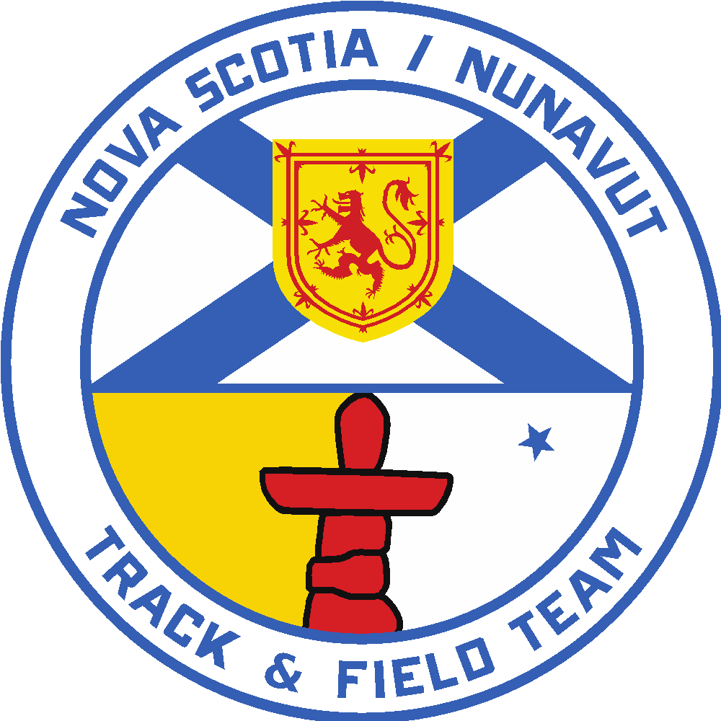

2026 Royal Canadian Legion National Youth
Track and Field Championships
Team Coach Position
Application Form

Note: This is for the Team Coach position only.

Applications for the positions of Team Coach of the 2026 Nova Scotia Legion Team must be received by Athletics Nova Scotia no later than April 1, 2026. Please submit by email to athleticstd@sportnovascotia.ca

The National Legion Championships Meet will be held in Calgary, AB from Aug. 7-9, 2026 (plus travel days – approx. August 5-11, 2026).

- All successful applicants will be required to submit a Criminal Record and Child Abuse Registry Check and sign an Athletics NS Code of Conduct

- All applicants must be current members of Athletics NS in good standing

Criteria to be considered for Team Coach Selection

The functions of a team coach is to provide coaching support to an event group(s) and maintain a positive environment for all those in attendance, including athletes, other coaches, chaperones, staff, support personnel and officials at all times.

- Must be a current member of Athletics Nova Scotia.
- Previous provincial team experience is considered an asset .
- Ability to contribute positively to the athletes’ and coaches over-all experience and has demonstrated that in the past as a coach.
- Strong supporter/believer of the benefits of the Legion Track and Field program.
- Has demonstrated previous contributions to Athletics Nova Scotia, its programs and athletes and is a strong advocate of the strategic priorities of Athletics NS.
- Coaches must be fully certified at Club Coach or Level 2 or equivalent at least three months prior to the Event. If the candidate has not already attained full NCCP Certification, they must submit a report detailing what components they must complete. This must also include an action plan that details how this will be accomplished by June 1, 2026.

Please be as detailed and specific as possible with your information. If more room is required, additional paper may be attached.

Name: ________________________________________________________________________

Address: ______________________________________________________________________

Telephone: (h) ____________________ (w) __________________

e-mail: _______________________________________________________________________

Current levels of NCCP certification: (Please indicate your highest level of certification obtained. ie. Sport Coach, Club Coach, Old NCCP etc.)

NCCP Coaching Number: __________________

Current NCCP Certification level: _________________________________________________

Comments:

What other coaching education courses or seminars have you completed?
Include course, location and date:

How many years have you been coaching? _______

How many athletes have you coached (in total)? _______

What age levels have you coached? _______

How many athletes do you currently coach? _______

Previous coaching experiences with provincial or national teams – please indicate team, date:

Future plans as a coach:

By being named to the NS Legion Team Coaching Staff, what benefits will result for the team, Athletics NS and you:

Additional team or club experience:

In what ways have you contributed to the Track and Field community in Nova Scotia:

Please feel free to attach a one-page resume if you feel there is important information about yourself that you were not able to relate in this application form. Individuals new to Athletics Nova Scotia may wish to include a letter of reference (preferably from a prominent member of the Athletics Nova Scotia Community).

Duties and Responsibilities
The Athletics Nova Scotia Legion Team Program has the following components. Attendance at each is mandatory. Athletes and staff applying to be on the Legion team must commit to the following:
- Legion Team Trials - July 11-12, 2026 – TBC, NS
- Atlantic Championships - July 25-26, 2026 - Truro, NS
- Legion Nationals - Regina, SK, August 7-9, 2026 (plus travel days)

Position Responsibilities
- Manages and coaches athletes of 1 or more event group.
- Communicates pertinent information to head coach and athletes.
- Reviews the entries of team members at time of registration.
- Attends technical meetings (when necessary) at team competitions and ensures proper information is relayed to team/staff members.
- Makes necessary changes regarding the athletes and their events (in consultation with the head coach and athletes themselves).
- Obligated to read and understand all aspects of the Legion Track and Field Championships Technical package.
- Must adhere to the Athletics Nova Scotia Professional Code of Conduct for Coaches.

