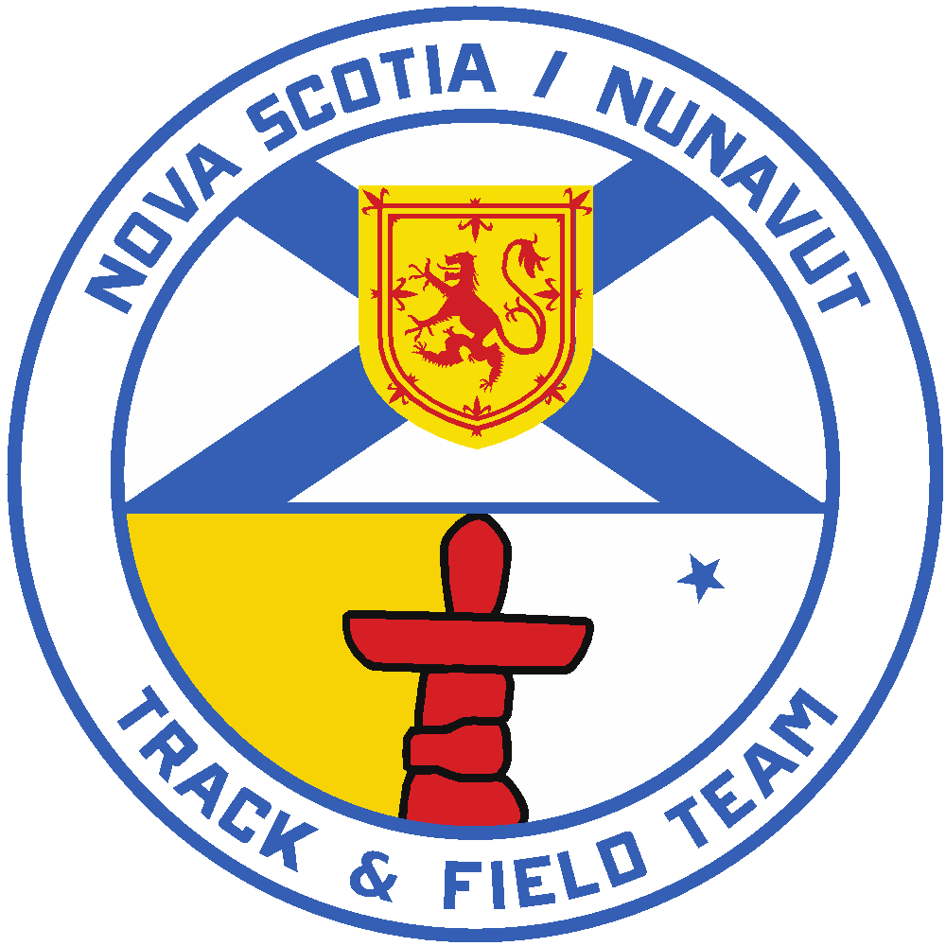

2026 Royal Canadian Legion National Youth
Track and Field Championships
Head Coach Position
Application Form

Applications for the position of Head Coach of the 2026 Nova Scotia Legion Team must be received by Athletics Nova Scotia no later than April 1st, 2026. Please email applications to athleticstd@sportnovascotia.ca

The National Legion Championships Meet will be held in Regina, SK from Aug. 7-9, 2026 (plus travel days – approx. August 5-11, 2026).

- All successful applicants will be required to submit a Criminal Record and Child Abuse Registry Check and sign an Athletics NS Code of Conduct

- All applicants must be current members of Athletics NS in good standing

Criteria to be considered for Head Coach Selection

The primary function of the head coach is to ensure technical management and oversight of the team and maintain a positive environment for all those in attendance, including athletes, other coaches, chaperones, staff, support personnel and officials at all times.

- Must be a current member of Athletics Nova Scotia.
- Previous provincial team experience is considered an asset .
- Ability to contribute positively to the athletes’ and coaches over-all experience and has demonstrated that in the past as a coach.
- Strong supporter/believer of the benefits of the Legion Track and Field program.
- Has demonstrated previous contributions to Athletics Nova Scotia, its programs and athletes and is a strong advocate of the strategic priorities of Athletics NS.
- Experience with conflict management and alternate dispute resolution will be considered an asset.
- Preference will be given to candidates who have previous experience coaching at national level events. Coaches must be fully certified at Performance Coach or Level 3 or equivalent at least three months prior to the Event. If the candidate has not already attained full Certification, they must submit a report detailing what components they must complete. This must also include an action plan that details how this will be accomplished by June 1, 2026.

Please be as detailed and specific as possible with your information. If more room is required, additional paper may be attached.

Name: ________________________________________________________________________

Address: ______________________________________________________________________

Telephone: (h) ____________________ (w) __________________

e-mail: _______________________________________________________________________

If not selected as Head Coach, would you like to be considered for Team Coach? __________

Current levels of NCCP certification: (Please indicate your highest level of certification obtained ie. Sport Coach, Club Coach, Old NCCP etc.)

NCCP Coaching Number: __________________

Current NCCP Certification level: _________________________________________________

Comments:

What other coaching education courses or seminars have you completed?
Include course, location and date:

How many years have you been coaching? _______

How many athletes have you coached (in total)? _______

What age levels have you coached? _______

How many athletes do you currently coach? _______

Previous coaching experiences with provincial or national teams – please indicate team, date:

Future plans as a coach:

By being named to the NS Legion Team Coaching Staff, what benefits will result for the team, Athletics NS and you:

Additional team or club experience:

In what ways have you contributed to the Track and Field community in Nova Scotia:

Please feel free to attach a one-page resume if you feel there is important information about yourself that you were not able to relate in this application form. Individuals new to Athletics Nova Scotia may wish to include a letter of reference (preferably from a prominent member of the Athletics Nova Scotia Community).

Duties and Responsibilities
The Athletics Nova Scotia Legion Team Program has the following components. Attendance at each is mandatory. Athletes and staff applying to be on the Legion team must commit to the following:
- Legion Team Trials – July 11-12, 2026 – TBC, NS
- Atlantic Championships - July 25-26, 2026 - Truro, NS
- National Legion Track and Field Meet - Regina, SK (August 7-9, plus travel days)

Position Responsibilities
- Communicates pertinent information to members of the Legion team.
- Coordinates training and competition arrangements for the team with the Team Manager, Athletics NS staff where applicable.
- Coordinates all team activities and team camps with the Team Manager and other staff members.
- Reviews the selection of team members at the Selection Meeting.
- In coordination with Team Manager, conducts and organizes team meetings.
- Submits all team entries into the competition by the registration deadline.
- Attends all relevant technical meetings at team competitions and ensures proper information is relayed to team/staff members.
- Makes necessary changes regarding the athletes and their events (in consultation with the other coaches and the athletes themselves).
- Delegates duties to other team staff.
- Obligated to read and understand all aspects of the Legion Track and Field Championships Technical package.
- Must adhere to the Athletics Nova Scotia Professional Code of Conduct for Coaches.

