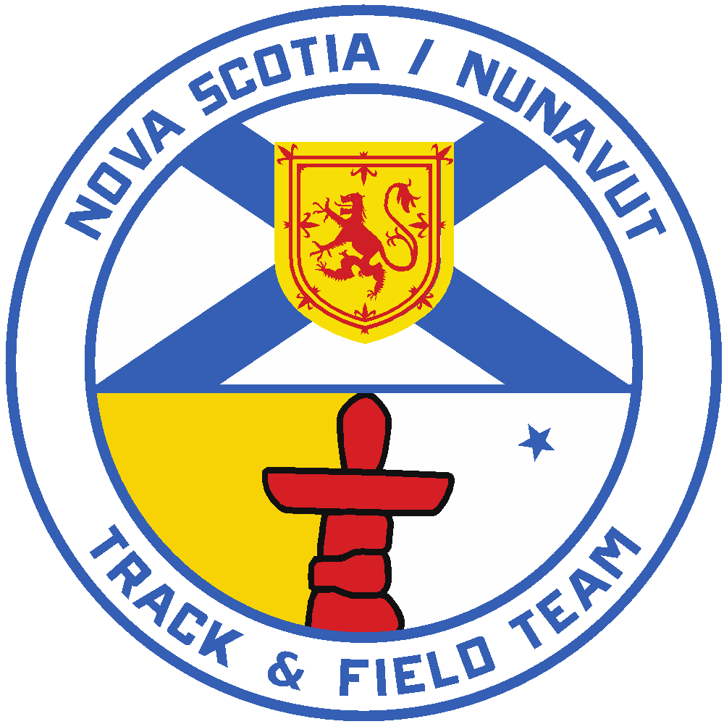

2026 Royal Canadian Legion National Youth
Track and Field Championships
Team Manager and Chaperone Positions
Application Form

Applications for the position of 1 Team Manager/Head Chaperone and 3 Chaperones for the 2026 Nova Scotia/Nunavut Legion Team must be received by Athletics Nova Scotia no later than April 1, 2026 at e-mail: athleticstd@sportnovascotia.ca

- Two males and two females will be selected to fill the four positions.

- All successful applicants will be required to submit a Criminal Record and Child Abuse Registry Check and sign an Athletics NS Code of Conduct

- All successful applicants will become Associate members of Athletics NS

Criteria to be considered for Chaperone Selection

The primary functions of the chaperone is to ensure the overall well-being of the athletes and maintain a positive environment for all those in attendance, including coaches, staff, support personnel and officials at all times.

- Candidates who are at least 25 years of age will be given preference.
- Chaperoning experience considered an asset (similar trips, youth group experience, training camps).
- Ability to contribute positively to the athletes’ and coaches over-all experience and has demonstrated in the past as a chaperone, parent, coach or supporter.
- First aid certified.
- Strong supporter/believer of the benefits of the Legion Track and Field program.
- Has demonstrated previous contributions to Athletics Nova Scotia, its programs and athletes and is a strong advocate of the strategic priorities of Athletics NS.
- Available for travel from approx. August 5-11, 2026
- References are required.

Legion Team Application for Chaperones and Manager

Please be as detailed and specific as possible with your information. If more room is required, additional paper may be attached.

Name: ________________________________________________________________________

Address: ______________________________________________________________________

Telephone: (h) ____________________ (w) ____________________ ext. ________

e-mail: _______________________________________________________________________

Indicate the position(s) you are applying for. You can apply for both:

( ) Team Manager/Head Chaperone ( ) Chaperone

Prior team staff experience, involving young athletes:

Summary of other experience in dealing with young athletes:

References:

Name: ______________________________

Email Address: ______________________________________________________

Phone Number: _______________

Name: ______________________________

Email Address: ______________________________________________________

Phone Number: _______________

Duties & Responsibilities

The four Chaperone positions (2 male and 2 female) are not to be confused with the Coaching positions. The Chaperone’s first line of duty is to be responsible for the general behavior and well-being of the athletes during all activities before, during and after the National Youth Championships.

Chaperones (3 required)
1. Be responsible for the general behavior and overall well-being of the athletes.
- Offer support to the Team Manager.
- Attend the day camp and the Atlantic Championships, assisting the coaching staff as required.
- Must live in residence for the duration of the Legion National Championships and be available to perform their duties 24 hours a day.
- Must be present at the track during competition days and at least two of the Chaperones must be at the track during the training days.
- Must ensure that all athletes adhere to the rules and regulations as outlined by the Royal Canadian Legion regarding curfews, discipline, absenteeism, property damage, possession of alcoholic beverages or drugs, etc.
- Must report disciplinary actions to the Head Coach.
- Must adhere to all rules and regulations set down by the Royal Canadian Legion and maintain a professional code of conduct when dealing with the team athletes, fellow staff members, meet officials and members of the Royal Canadian Legion.

Head Chaperone/Team Manager (1 required)

- Adhere to the duties of a Chaperone as noted above although it is understood that the other 3 Chaperones will offer their support to help lighten the load.
- In consultation/coordination with the Executive Director of Athletics NS and Legion Representative, ensure all arrangements regarding the day camp, team uniforms, transportation and other preparations are completed and relayed to team members/staff prior to the competition.
- Lays out the guidelines for appropriate team behavior of team members as outlined by the Royal Canadian Legion and Athletics NS.
- Ensures evaluation forms are distributed to the athletes and returned to the ANS Executive Director.
- In consultation with the other Chaperones, submits a short written report to the ANS Executive Director within two weeks of returning home from the competition outlining observations of the trip and recommendations for future years.

Please note: The cost of traveling to and attending the Legion National Championships is covered, in its entirety, by the Royal Canadian Legion.

